Create a bash script to check if a directory is available or not.
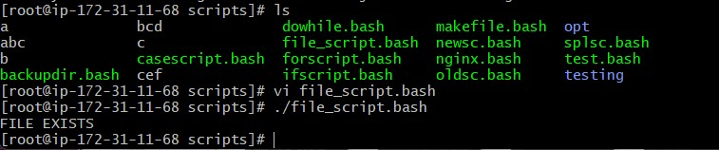
Create a bash script to create multiple files.
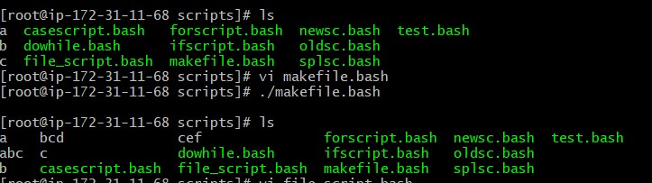
Create a bash script to take a backup of a directory.
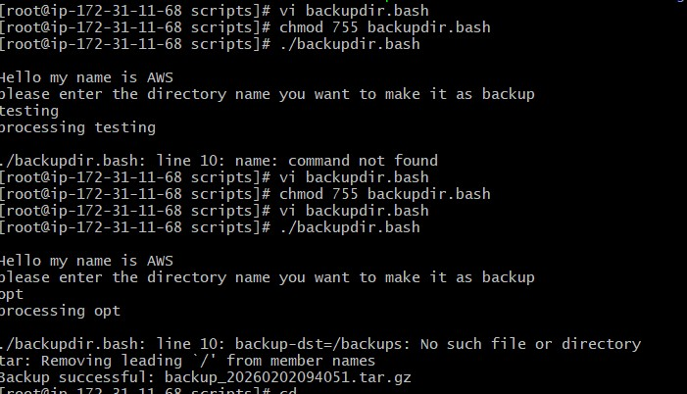

Create a bash script to install Nginx on an EC2 server.
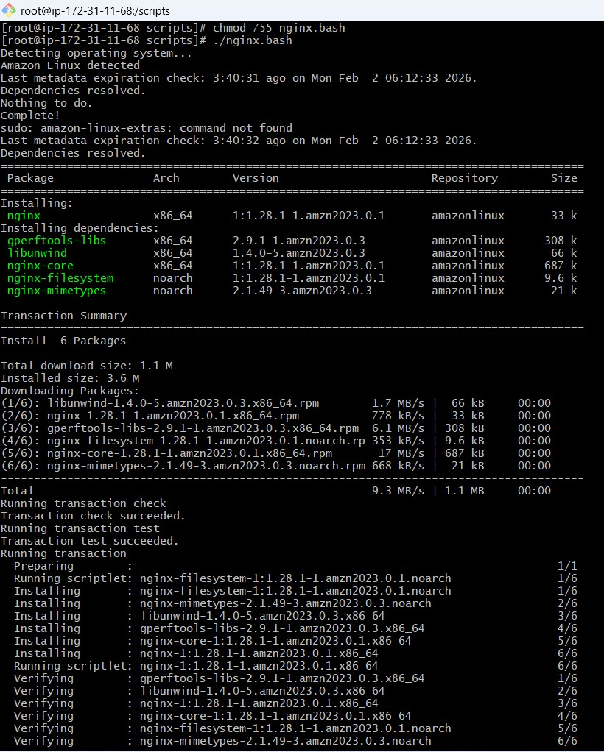
Create a bash script to install Apache Tomcat on an EC2 server.
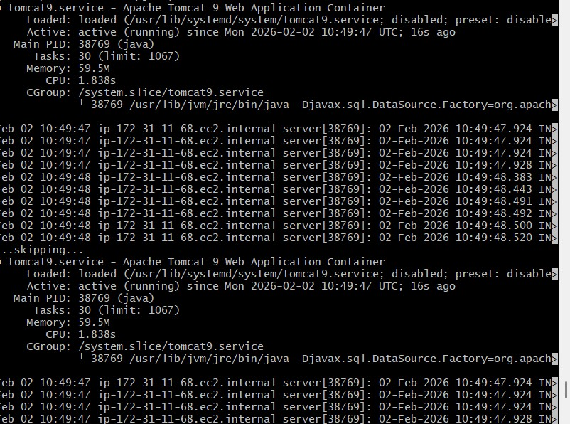
Create a bash script to check if the Nginx service is running, if not running then script should start the service.
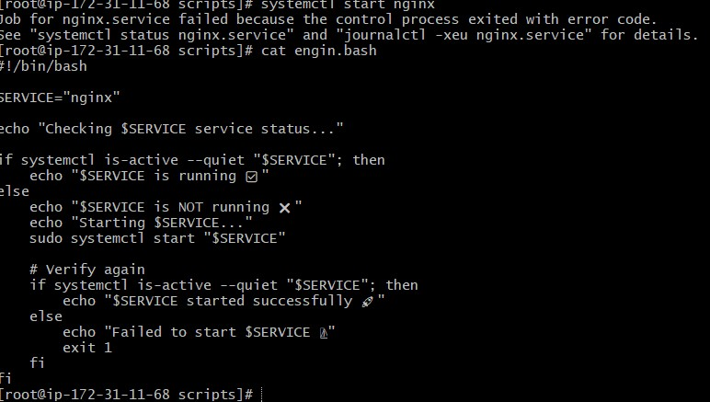

Create a bash script for a calculator.
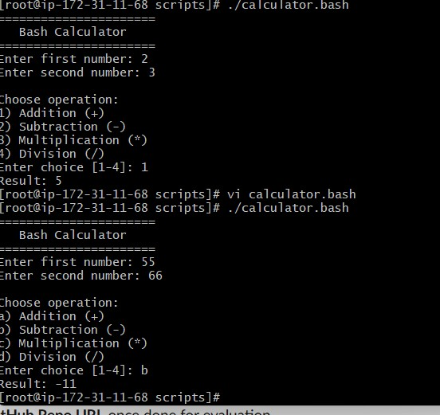
Create a bash script to delete the last 3 lines of a file.

Bash script to monitor cpu and if it is more than 80% then send email notification.
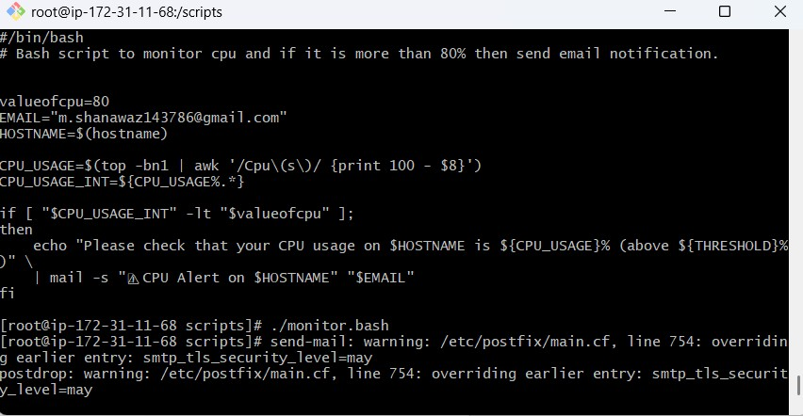

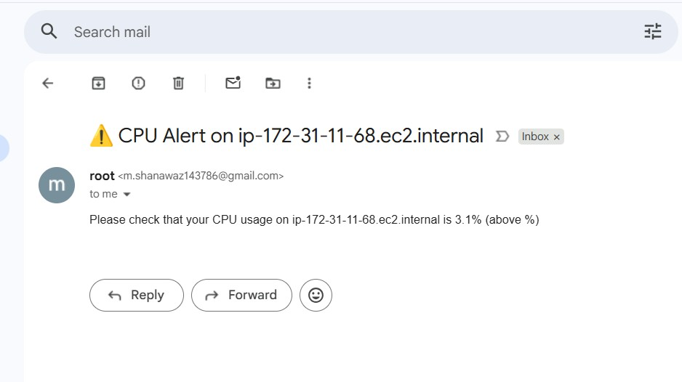
Bash script to monitor disk space and if it is more than 80% then send email notification.
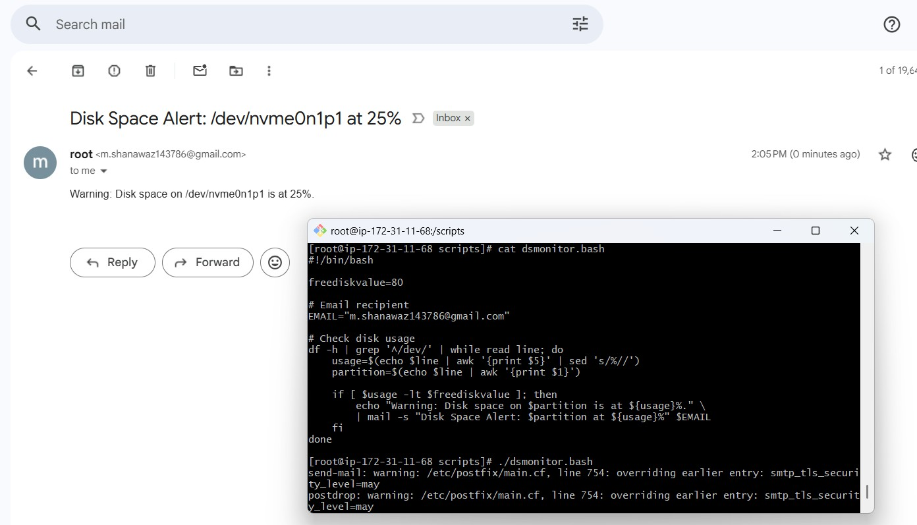

Bash script to monitor memory and if it is more than 80% then send email notification.
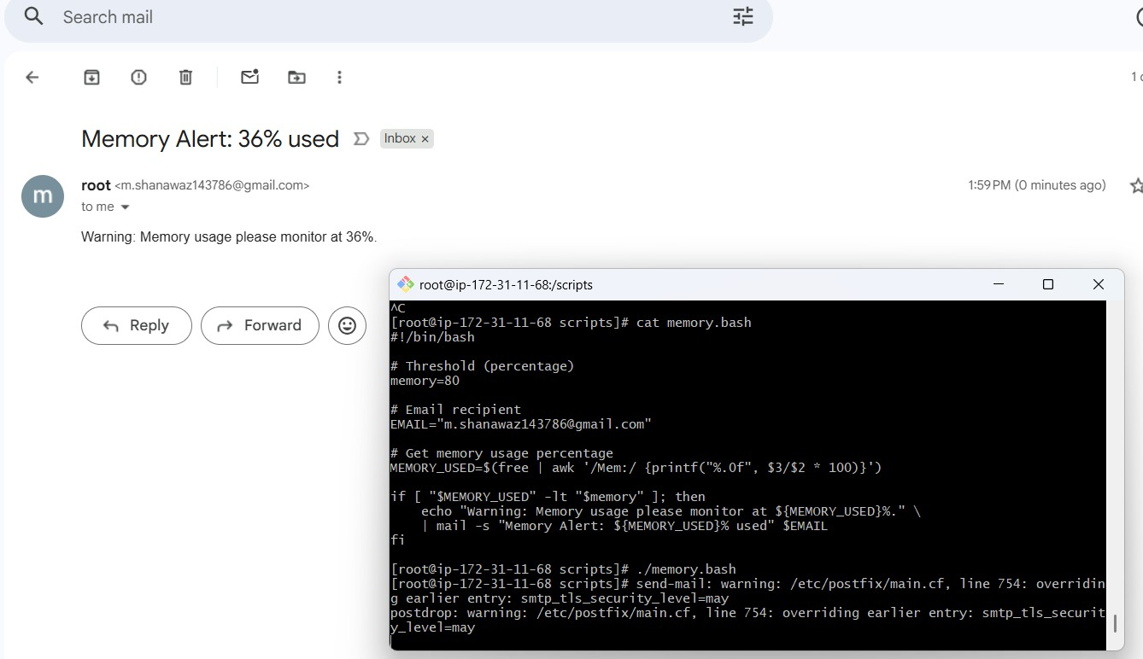
At 05 and 27th minutes of 9, 10, 11 hours every day
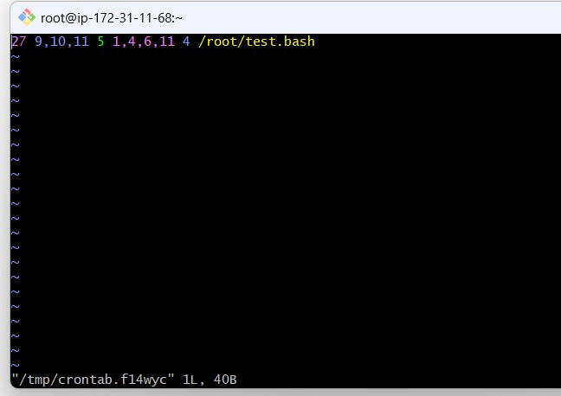

34 minutes of 9th hour on 15th August Every midnight
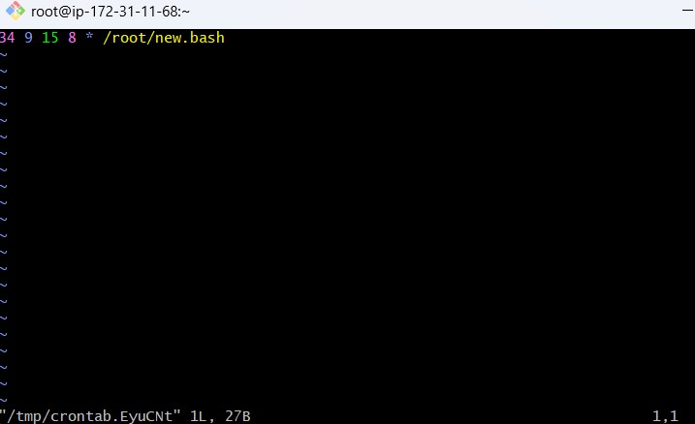
Every Weekend (Saturday night 11:59 PM)
